Instructions for Preparing

Supplemental Reporting Submissions



Department of Planning and Budget
October 2014

TABLE OF CONTENTS
Supplemental Reporting Submission Overview 1
What reporting information is involved? 1
Where do I report this information? 1
When is the submission due? 1
Reporting 2
Attachment A: Supplemental Reporting Module Instructions 3
Decision Package Module Quick Guides 4
Overview Tab Overview 5
Overview Tab Instructions 5
Federal Funding Tab Overview 6
Federal Funding Tab Instructions 6
Organizational Membership Tab Overview 7
Organizational Membership Tab Instructions 7
Out Year Funding Tab Overview 8
Out Year Funding Tab Instructions 8

Supplemental Reporting Submission Overview

The Department of Planning and Budget (DPB) is responsible for gathering and processing agency submissions of “supplemental reporting” –- information providing data on federal grants, organizational memberships, and out-year costs. For that purpose, this notice issues guidance to state agencies on preparing the submissions to be reviewed by DPB and subsequently shared with the Governor’s office and the General Assembly.
What reporting information is involved?
- Federal grants. If applicable, agencies are to provide a listing and general description of any federal contract, grant, or money in excess of $1.0 million for which the agency was eligible, whether or not the agency applied for, accepted, and received such contract, grant, or money, and, if not, the reasons for why it did not apply. Responses should be based on the current fiscal year.
- Organizational Memberships. If applicable, agencies are to report on organizational memberships with annual dues of $5,000 or more. Responses should reflect what is budgeted (GF and NGF) in FY 2015. (Section 4-5.05 exempts institutions of higher education.)
- Out Year Costs. If applicable, agencies are to identify any anticipated out-year spending increases or decreases that were not submitted as part of a decision package. For example, a new building or facility will be coming on line in September 2017 for which operating costs are anticipated. Since additional funding for this new facility is not required in the 2014-2016 biennium, no decision package would be submitted. The Out Year Costs tab of the Supplemental Reporting module is where such costs should be identified.
Where do I report this information?
All submissions will be made using DPB’s Performance Budgeting (PB) system. The Supplemental Reporting module can be found in the drop-down list of the OPERATING BUDGET index tab on the PB system’s Work Tray. A detailed user guide on how to prepare the submission is contained within the HELP feature available in the Supplemental Reporting module (also provided in Attachment A below).

When is the submission due?
PB system submissions are to be completed by Friday, November 14, 2014. If none of the three reporting requirements are applicable to your agency, please let your DPB budget analyst know.
Please contact your DPB budget analyst if you have any questions.
Reporting
After completing your Supplemental Reporting submission, you may run a report showing your entries by clicking on the “BD7.10 - Supplemental Reports” report within the Performance Budgeting system reports menu. This report contains several options that allow you to run detailed reports on the status and contents of your submission.
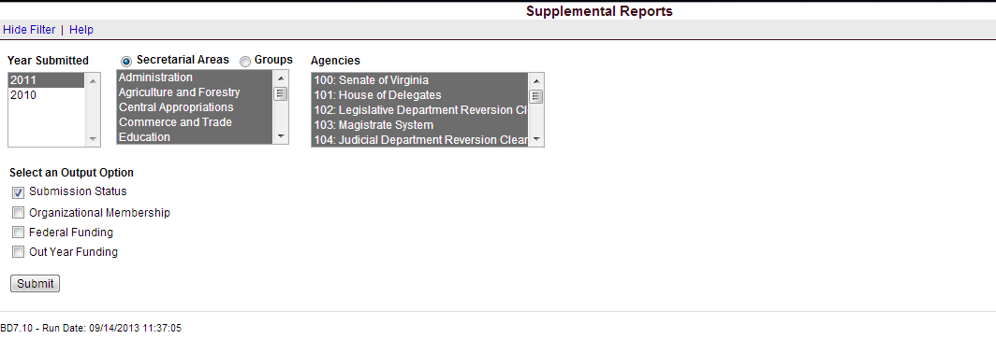

Attachment A: Supplemental Reporting Module Instructions - Performance Budgeting System

Note: The following information is an extract from the PB system HELP feature in the Supplemental Reporting module. If after reading these detail instructions you have any questions of a policy nature, please contact your DPB budget analyst. If you experience technical issues with the Performance Budgeting System, please contact the VCCC help desk at vccc@vita.virginia.gov (make sure to indicate in the subject line that you are experiencing a Performance Budgeting System issue so the ticket can be routed to the Performance Budgeting System help desk).

With exception to institutions of higher education for organizational memberships, each state agency (all branches of government) is required to report on the following information annually:
- Federal grants. Listing and general description of any federal contract, grant, or money in excess of $1.0 million for which the agency was eligible, whether or not the agency applied for, accepted, and received such contract, grant, or money, and, if not, the reasons for which it did not apply. This should be based according to the state fiscal year.
- Organizational Memberships. In addition, the Appropriation Act requires all agencies to report on organizational memberships with annual dues of $5,000 or more. (Section 4-5.05 exempts institutions of higher education.)
- Out Year Costs. Agencies may anticipate out-year spending increases or decreases that may not be submitted as part of a decision package. For example, a new building or facility may be coming on line in September 2017 for which operating costs are anticipated. Since additional funding for this new facility is not required in the current biennium, no decision package would be submitted. To capture any anticipated appropriation needs for the future biennia for which your agency is not submitting a decision package, you must complete an Out-Year Cost Estimates.

Decision Package Module Quick Guides

AGENCY ANALYST QUICK GUIDE
- Mouse over the Operating Budget Functional Area menu item and select Supplemental Reporting from the resulting dropdown menu. Once supplemental reporting is selected, the Overview tab will appear.
- Complete the Overview tab as described in the Overview tab instructions.
- Complete the Federal Funding tab as described in the Federal Funding tab instructions (if applicable).
- Complete the Organizational Membership tab as described in the Organizational Membership tab instructions (if applicable).
- Complete the Out Year Funding tab as described in the Out Year Funding tab instructions (if applicable).
- Click Submit and select the appropriate action from the available options:
  - Continue Working - Saves the supplemental reporting work item and returns it to the Available Work Items tab on the Work Tray for users with similar credentials to claim.
  - Submit for Agency Review - Submits the supplemental reporting work item to the next step in the workflow.
  - Void Document - Voids the supplemental reporting work item.

AGENCY REVIEWER QUICK GUIDE
- Click on Available Work Items from the Work Tray.
- Select the Document Type filter and select Supplemental Reporting to filter on the supplemental reporting.
- Click Claim next to a proposed supplemental reporting that is ready for review. Once the supplemental reporting work item is claimed, the Overview tab will appear.
- Review the Overview tab for completeness and accuracy.
- Click on the Federal Funding tab and review for completeness and accuracy.
- Click on the Organizational Membership tab and review for completeness and accuracy.
- Click on the Out Year Funding tab and review for completeness and accuracy.
- Click Submit and select the appropriate action from the available options.
  - Continue Review - Saves the supplemental reporting work item and returns it to the Available Work Items tab on the Work Tray for users with similar credentials to claim.
  - Submit for DPB Review - Submits the supplemental reporting work item to DPB.
  - Return for Further Data Entry - Returns the supplemental reporting work item to the data entry workflow step.
  - Void Document - Voids the supplemental reporting work item.

Overview Tab

Overview Tab Overview
The purpose of the Overview tab is specify the agency to which the supplemental reporting information applies and which supplemental reporting forms are valid for that agency.
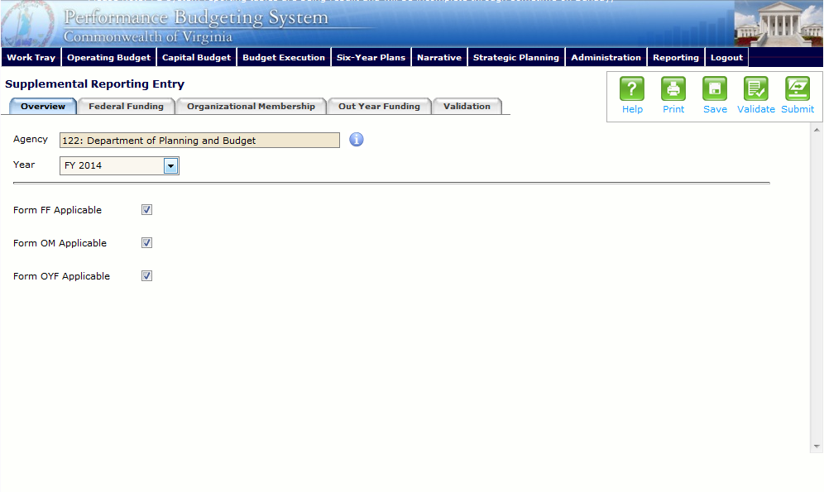
Overview Tab Instructions
- Click on the Overview tab.
- Select the Agency that the supplemental reporting forms are for.
- Confirm that it is the correct Year for the supplemental reporting forms.
- Check the Form FF Applicable checkbox if the agency receives federal funding. Once checked, the Federal Funding tab will appear.
- Check the Form OM Applicable checkbox if the agency has organizations (with memberships costing $5,000 or more) to which it belongs. Once checked, the Organizational Membership tab will appear.
- Check the Form OYF Applicable checkbox if the agency has out year funding that they will need. Once checked, the Out Year Funding tab will appear.

Federal Funding Tab

Federal Funding Tab Overview
The purpose of the Federal Funding tab is to capture information pertaining to the federal funding an agency receives. This should include a listing and general description of any federal contract, grant, or money in excess of $1,000,000 for which the agency was eligible, whether or not the agency applied for, accepted, and received such contract, grant, or money, and, if not, the reasons for which it did not apply. This should be based according to the state fiscal year.
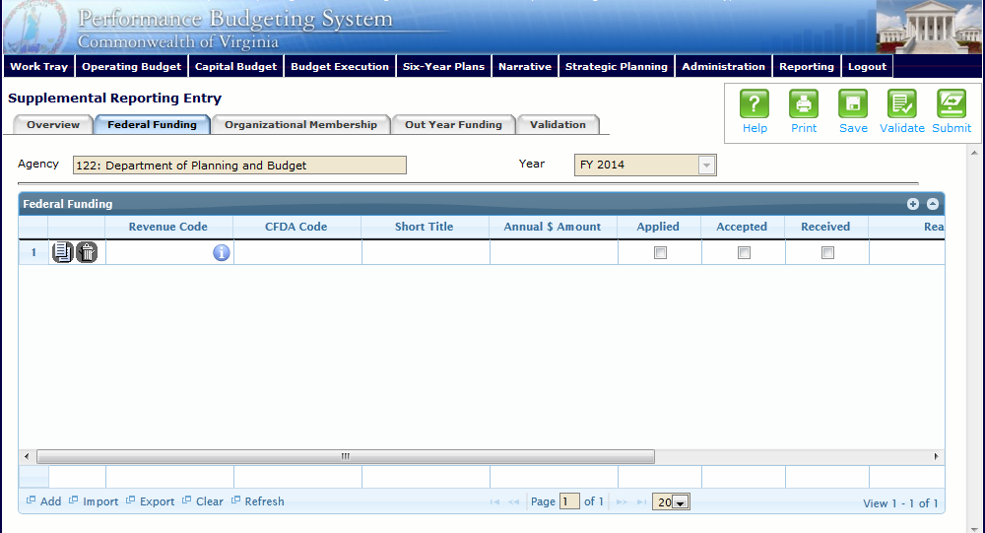
Federal Funding Tab Instructions
- Click on the Federal Funding tab.
- In the Federal Funding grid, select the Revenue Code for the Federal Funding. Insert the appropriate Commonwealth revenue source code.
- Enter the CFDA Code for the federal funding. Insert the appropriate Catalog of Federal Domestic Assistance code.
- Enter a Short Title for the federal funding. Insert a short title starting with an action verb that describes the federal funding.
- Enter the Annual $ Amount of the federal funding.
- Check the Applied, Accepted, and/or Received checkboxes as applicable for the federal funding.
- Enter a Reason for not applying for, accepting, or receiving the Federal Funding as applicable.
- Add rows to the Federal Funding grid as needed to specify additional federal funding sources by clicking the Add button.

Organizational Membership Tab

Organizational Membership Tab Overview
The purpose of the Organizational Membership tab is to capture information pertaining to the organizations to which an agency is a member that is $5,000 or greater.
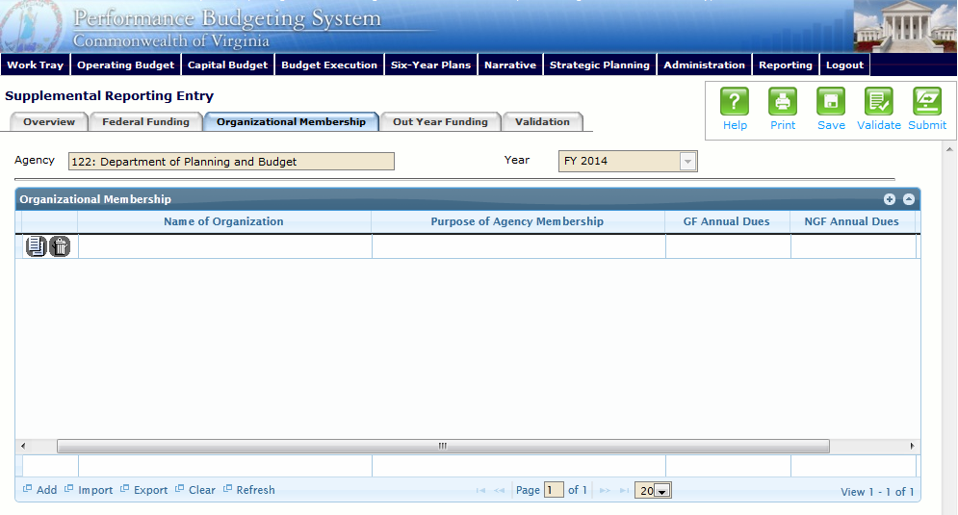
Organizational Membership Tab Instructions
- Click on the Organizational Membership tab.
- In the Organizational Membership grid, enter the name of the organization in the Name of Organization field.
- In the Organizational Membership grid, enter the Purpose of the Agency Membership.
- In the Organizational Membership grid, enter the GF and NGF Annual Dues for the organizational membership.
- Add rows to the Organizational Membership grid as needed to specify additional organizational memberships by clicking the Add button.

Out Year Funding Tab

Out Year Funding Tab Overview
The purpose of the Out Year Funding tab is to capture the information pertaining to the out year funding that an agency anticipates needing.
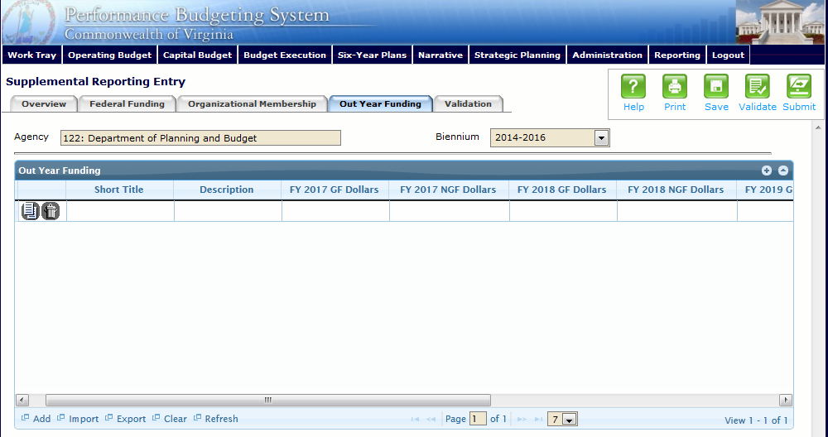
Out Year Funding Tab Instructions
- Click on the Out Year Funding tab.
- In the Out Year Funding grid, enter a Short Title for the out year funding.
Insert a short title starting with an action verb that describes the item for which you are reporting anticipated out-year costs, (e.g. a new building or facility may be coming on line in September 2018 for which operating costs are anticipated. Since additional funding for this new facility is not required in the current biennium, no decision package would be submitted.)
- In the Out Year Funding grid, enter a Description for the out year funding.
Provide a short description for the item for which you are reporting anticipated out-year costs.
- In the Out Year Funding grid, enter the FY 20XX GF and NGF Out Year Funding, where 20XX is the first out year for the current or next biennium. If the funding is 0, leave cell blank.
- In the Out Year Funding grid, enter the FY 20XX GF and NGF Out Year Funding, where 20XX is the second out year for the biennium. If the funding is 0, leave cell blank.
- In the Out Year Funding grid, enter the FY 20XX GF and NGF Out Year Funding, where 20XX is the third out year for the biennium. If the funding is 0, leave cell blank.
- In the Out Year Funding grid, enter the FY 20XX GF and NGF Out Year Funding, where 20XX is the fourth out year for the biennium. If the funding is 0, leave cell blank.
- Add rows to the Out Year Funding grid as needed to specify additional Out Year Funding by clicking the Add button.

